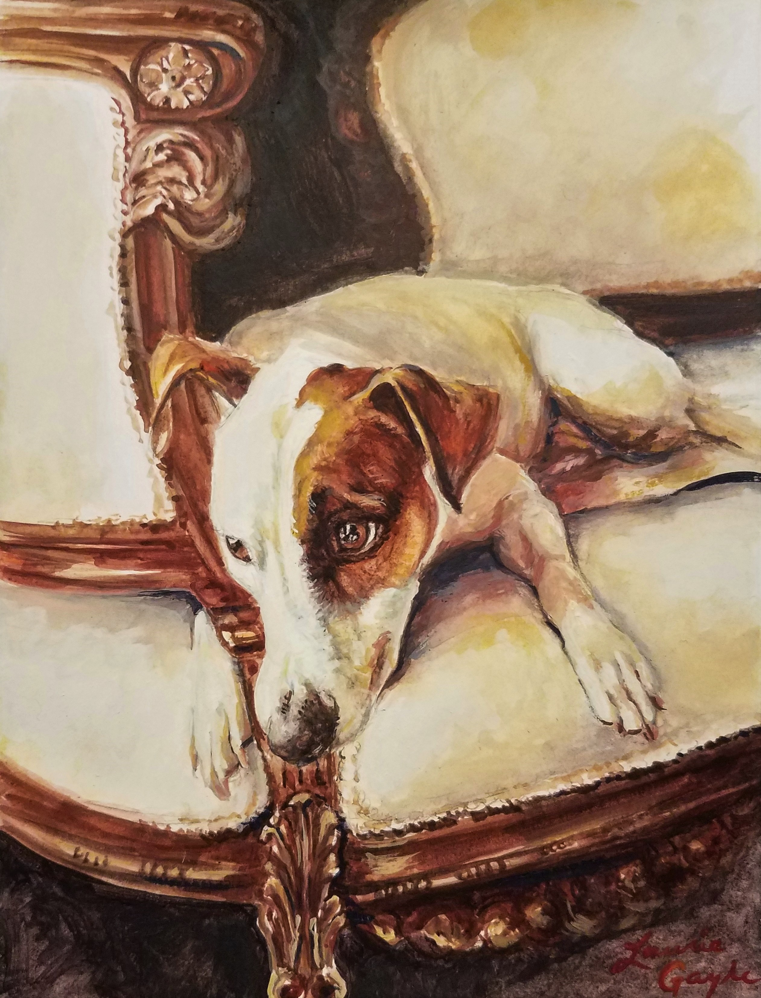

PORTRAITURE PRICE LIST

www.animalportraitsbylauriegayle.com
lagayle63@gmail.com
919-812-4402

Animal
SIZE | COLOR PENCIL | WATERCOLOR | OIL
5 x 7 | NA | 200.00 | 300.00
6 x 8 | NA | 300.00 | 400.00
8 x 10 | 600.00 | 400.00 | 675.00
9 X 12 | 650.00 | 425.00 | 775.00
11 x 14 | 750.00 | 450.00 | 950.00
12 x 16 | 875.00 | 550.00 | 1000.00
16 x 20 | 1200.00 | 750.00 | 1600.00
18 x 24 | 1300.00 | 850.00 | 1750.00
22 x 30 | 1800.00 | 1200.00 | 2250.00
Over 22 x 30 | NA | NA | 2500.00 +

